**User Guide for**

**J.A.W.S. Procurement Software**

**Version 1.0.1 - 27 November 2022**

**J.A.W.S. Procurement LTD ||** [**inquiry.jaws@support.ca**](mailto:support.jaws@inquiry.ca) **||+1(800)-900-3001|| www.jawsltd.ca**

**Table of contents**

[**1.**](https://docs.google.com/document/d/1zSVJa6TYadvH8PKt8u7CK32bYSWZ2lhucp-CRYvR9Dk/edit#heading=h.rf92mwf2og1v) **General** [**1**](https://docs.google.com/document/d/1zSVJa6TYadvH8PKt8u7CK32bYSWZ2lhucp-CRYvR9Dk/edit#heading=h.rf92mwf2og1v)

[1.1.](https://docs.google.com/document/d/1zSVJa6TYadvH8PKt8u7CK32bYSWZ2lhucp-CRYvR9Dk/edit#heading=h.r0gle6rww91t) Introduction and Purpose

[1.2.](https://docs.google.com/document/d/1zSVJa6TYadvH8PKt8u7CK32bYSWZ2lhucp-CRYvR9Dk/edit#heading=h.b81h14tr86kc) Project References

[1.3.](https://docs.google.com/document/d/1zSVJa6TYadvH8PKt8u7CK32bYSWZ2lhucp-CRYvR9Dk/edit#heading=h.2z3u3fgn9sn5) Glossary

[**2.**](https://docs.google.com/document/d/1zSVJa6TYadvH8PKt8u7CK32bYSWZ2lhucp-CRYvR9Dk/edit#heading=h.1zl9pgjxfi7x) **System Overview** [**2**](https://docs.google.com/document/d/1zSVJa6TYadvH8PKt8u7CK32bYSWZ2lhucp-CRYvR9Dk/edit#heading=h.1zl9pgjxfi7x)

[2.1. S](https://docs.google.com/document/d/1zSVJa6TYadvH8PKt8u7CK32bYSWZ2lhucp-CRYvR9Dk/edit#heading=h.b5of7wcpcfxi)ystem Application

[2.2.](https://docs.google.com/document/d/1zSVJa6TYadvH8PKt8u7CK32bYSWZ2lhucp-CRYvR9Dk/edit#heading=h.hqepaev8mrl1) System Organization

2.3. Software Inventory

**3. System Structure 3**

3.1. Layout

3.2. Menus

3.3. Functionalities

**4. Reference Documents 12**

1. **General**

1.1. Introduction and Purpose

The purpose of this manual is to assist users in getting acquainted with the J.A.W.S. Procurement system. Otherwise put, it serves to provide instructions and guidelines for the usage of this software.

1.2. Project References

Other pertinent documents include the “Installation Guide for J.A.W.S. Procurement Software”.

[**2.**](https://docs.google.com/document/d/1zSVJa6TYadvH8PKt8u7CK32bYSWZ2lhucp-CRYvR9Dk/edit#heading=h.1zl9pgjxfi7x) **System Overview**

[2.1. S](https://docs.google.com/document/d/1zSVJa6TYadvH8PKt8u7CK32bYSWZ2lhucp-CRYvR9Dk/edit#heading=h.b5of7wcpcfxi)ystem Application

The application J.A.W.S. Procurement Software is designed to automate material acquisition of all types of businesses. It serves as a middle ground between suppliers and businesses. The system allows end users to request item purchase which results in automatically requesting quotations from suppliers of these items.In the case that the lowest quotation is below 5000$, the system will initiate the purchase. On the other hand, if the lowest quotation is above 5000$, the system will require at least 2 quotations before submitting the request to the user’s supervisor for approval. If approved, the system will commence the purchase, and if not, the end user will be informed and the procurement request will close.

[2.2.](https://docs.google.com/document/d/1zSVJa6TYadvH8PKt8u7CK32bYSWZ2lhucp-CRYvR9Dk/edit#heading=h.hqepaev8mrl1) System Organization

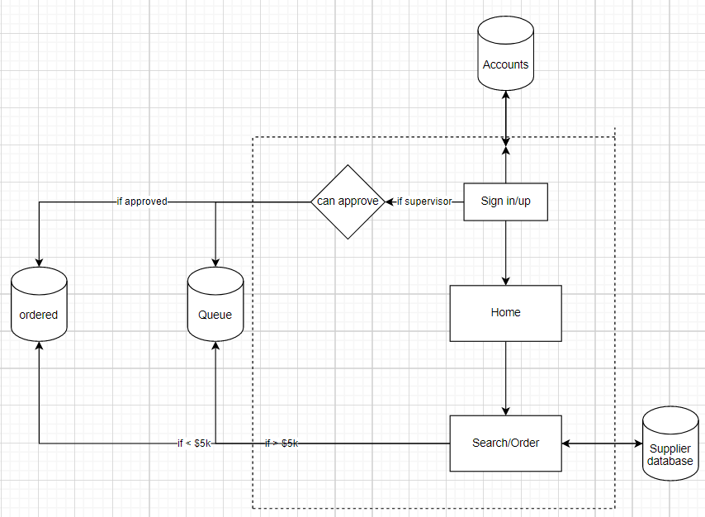

*Figure 1: Logic Diagram*

[2.3.](https://docs.google.com/document/d/1zSVJa6TYadvH8PKt8u7CK32bYSWZ2lhucp-CRYvR9Dk/edit#heading=h.b5of7wcpcfxi) Software Inventory

The software required to run this application:

* PHP language
* Windows 8 or higher; Mac OS X 10.7
* Any IDE
* Web browser

**3**[**.**](https://docs.google.com/document/d/1zSVJa6TYadvH8PKt8u7CK32bYSWZ2lhucp-CRYvR9Dk/edit#heading=h.1zl9pgjxfi7x) **System Structure**

3.1. Layout

Website Sign-In page:

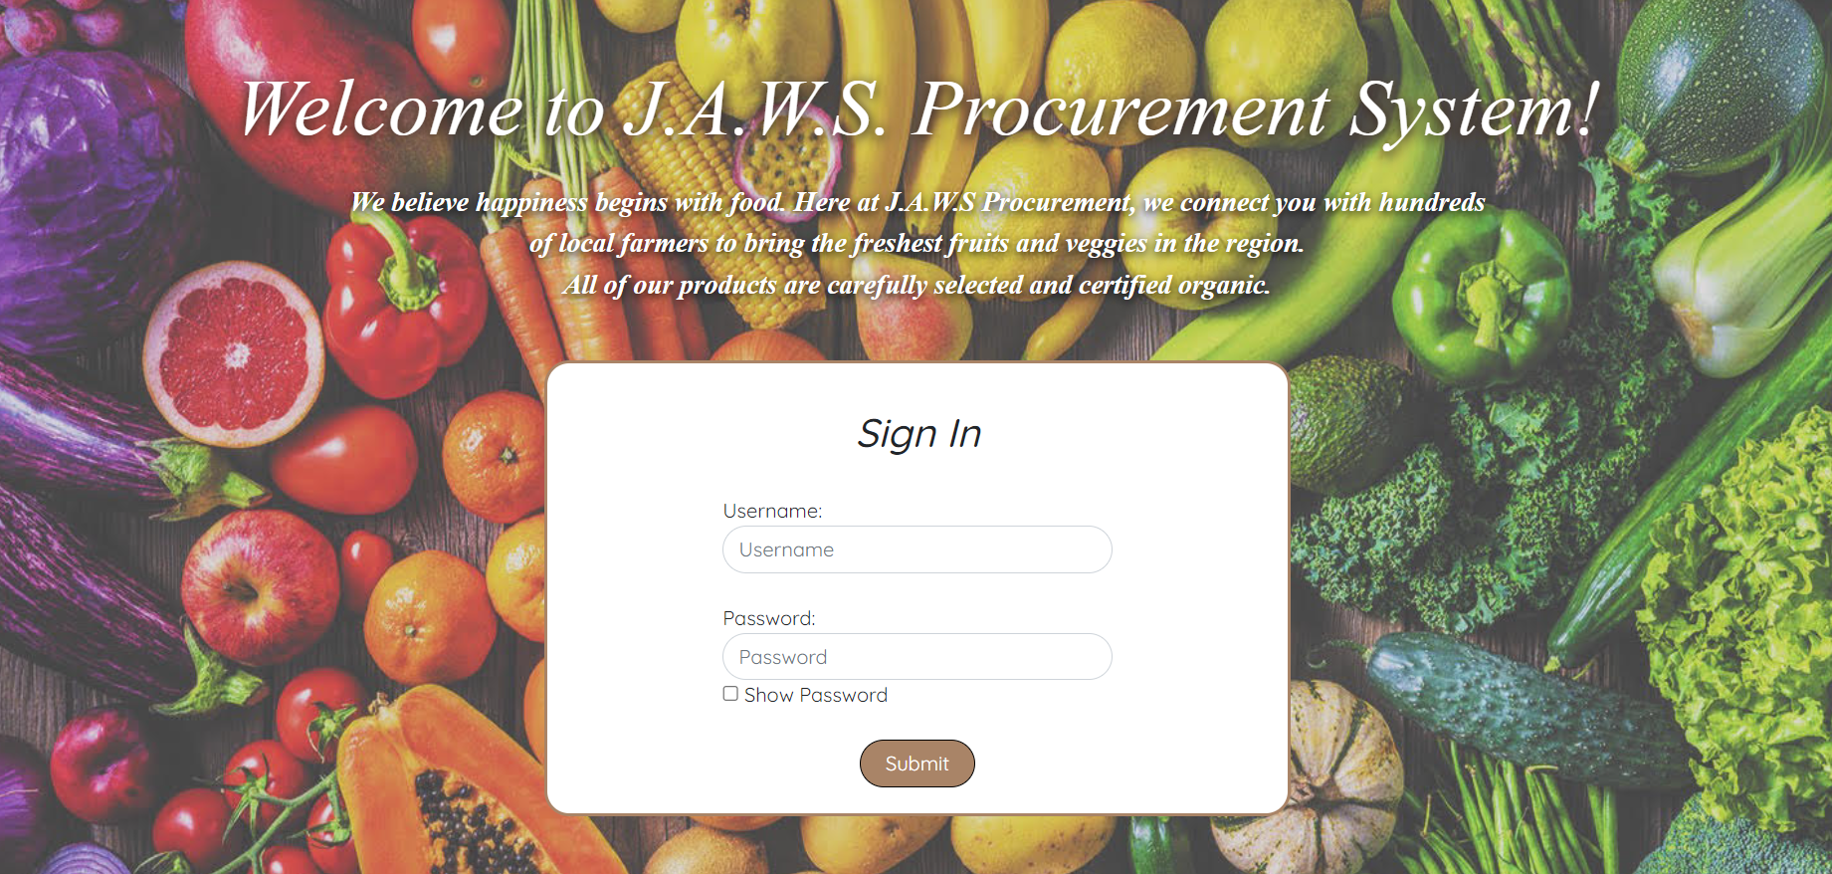

Adding a new user:

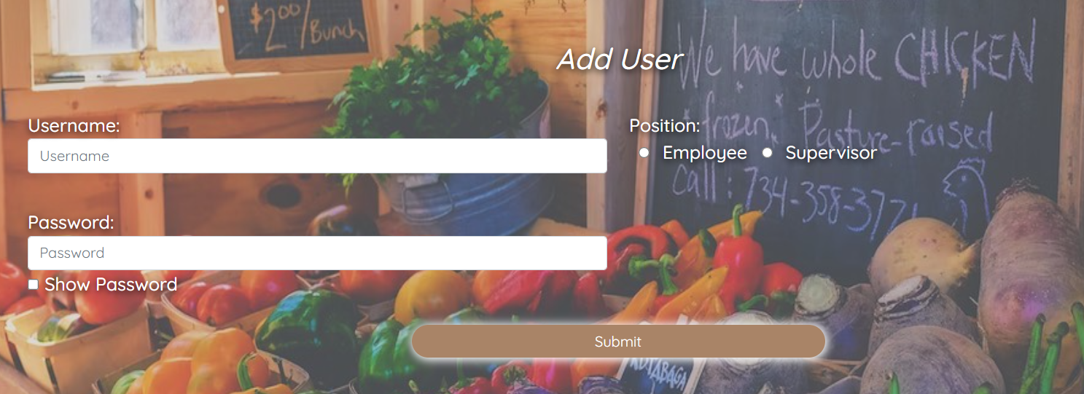

User List:

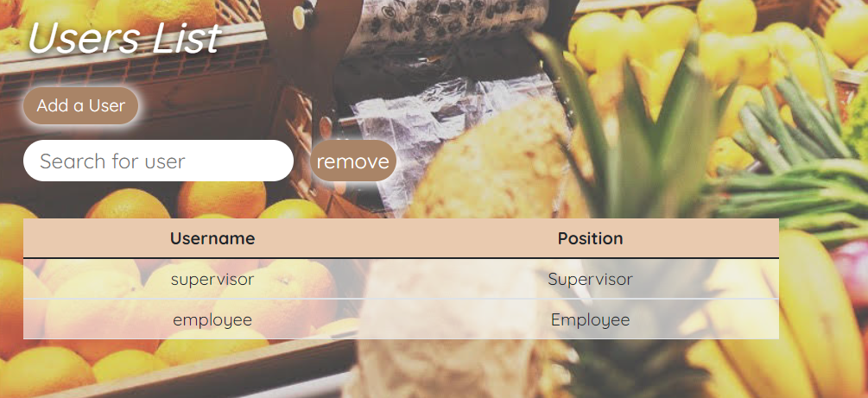

Adding a Product:



Product List:

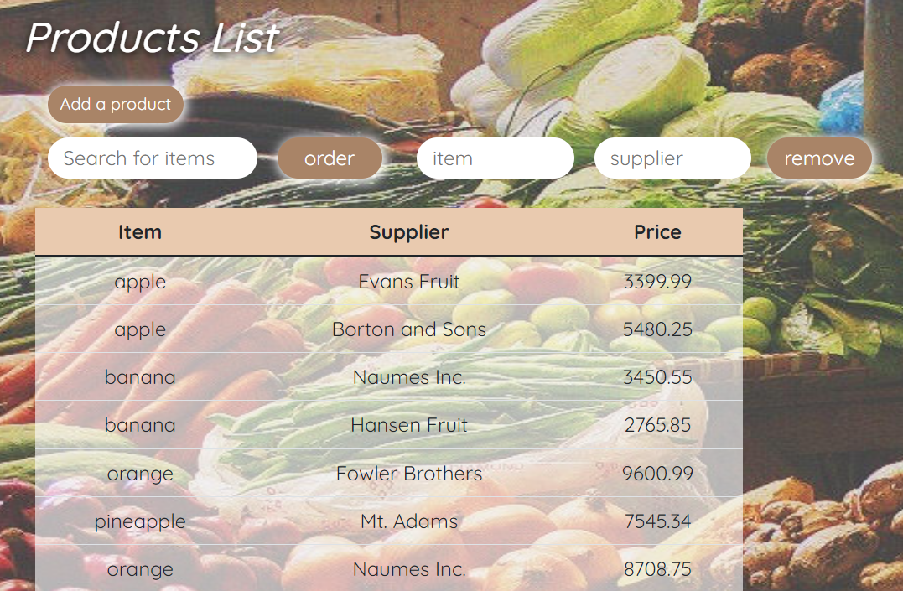

Order List:

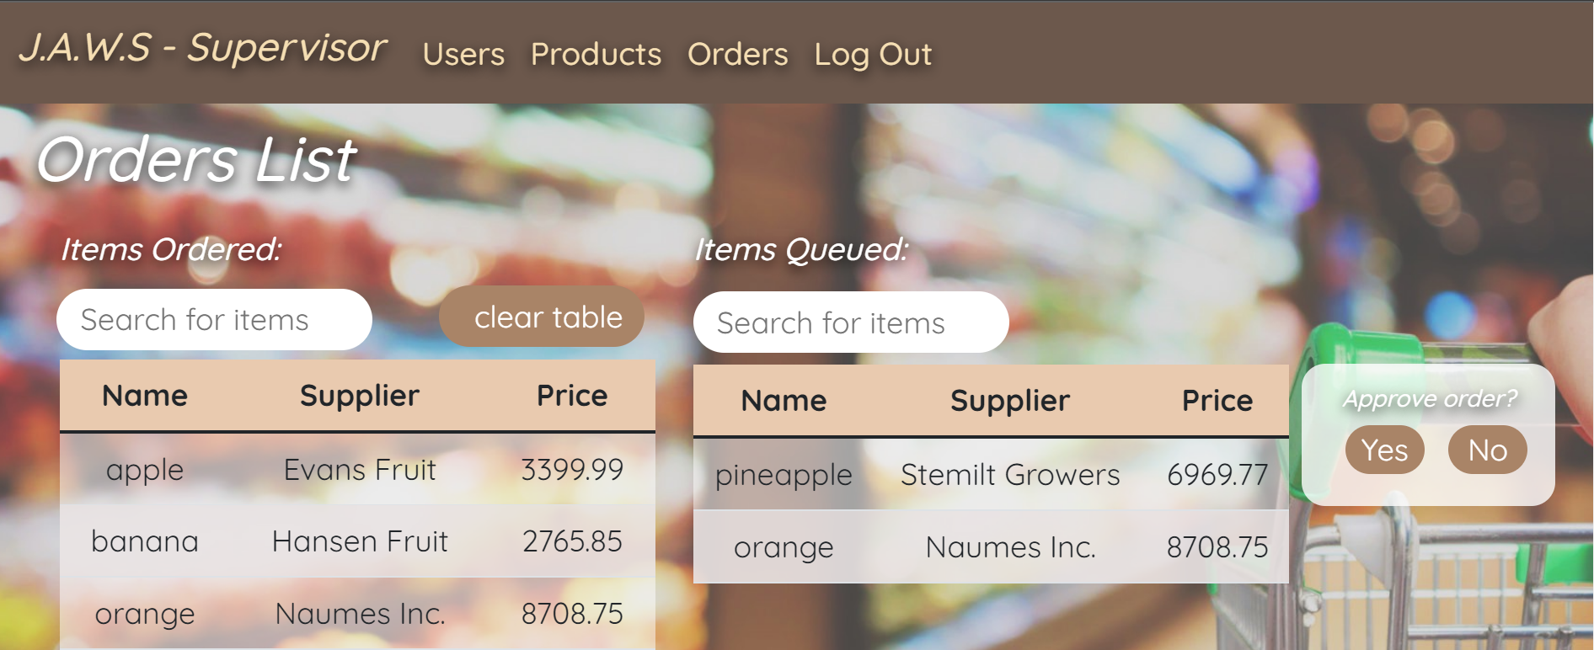

3.2. Menus

| **Menu** | **Description** |
| --- | --- |
| Home | Allows the user to sign-in. |
| Add User | Used to add new users. |
| User List | Displays a list of users and their position. |
| Add Product | Allows the users to add products. |
| Product List | Displays a list of the products added, their supplier and their price. |
| Orders List | Displays a list of items ordered and a list of items queued. |

3.3. Functionalities

1. Home:

Prompts users to sign-in by inserting:

* Username
* Password

1. Add User:

Allows the addition of new users and selecting the user position.

Functionalities:

* Username entree
* Password entree
* Position selection
* Supervisor
* Employee

1. User List:

Displays a list of the users and their selected position.

Functionalities:

* Searches for users
* Removes a user
* Takes the user to the “Add User” page to add a user

1. Add Product:

Prompts the user to enter a product, choose the product supplier and select the price range for the product.

Functionalities:

* Product selection by allowing the user to enter a product name
* Choosing the supplier by entering the supplier name/code
* Allows the user to enter the price range for the product selected

1. Product List:

Displays a list of the items selected with the supplier and the price.

Functionalities:

* Allows users to search for items
* Orders the item selected which adds the item to the “Order list”
* Removes a selected item from the list
* Adds a new product to the list by taking the user to the “Add Product” page

1. Order List:

Displays a list for items ordered and a separate list for items queued.

Functionalities:

* Search for items in the “Items Ordered” list
* Search for items in the “Items Queued” list
* Suppervisor approve/decline of “Items Queued”
* Supervisor “Clear table” button to clear “Items Ordered” table

**4. Reference Document**

| **Title** | **Description** |
| --- | --- |
| Installation Guide | Guide on how to install the system and components for the website to work. |